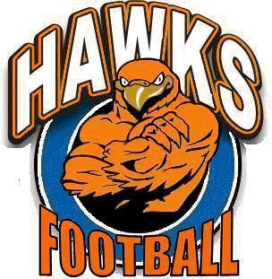
Hayfield Football
2018 Mulch Sale
Bags contain 3-cubic feet of mulch for $5.00 per bag
Free Delivery – Delivery Donations Accepted
Orders must be received by Monday, March 26, 2018
Delivery Date is Saturday, April 7

**For additional information on the mulch sale or to order securely online visit www.hayfieldfootball.com.**
You may also order with a check or money order by mailing in this order form.

Delivery Information
Name: _____________________________________________________________
Neighborhood: ______________________________________________________
Address: ___________________________________________________________
Phone number: (H): _____________________ (C): ______________________
Email: _____________________________________________________________
Delivery Instructions: _________________________________________________
___________________________________________________________________

Pay with Check or Money Order
Make checks payable to: Hawks Athletic Boosters, Inc.
P.O. Box 151172
Alexandria, VA 22315
Please attach check or money order to this form
# of Bags _________
X $5.00 per bag _________
Donation _________
Total Payment _________

Order and pay online with a credit or debit card
Go to www.hayfieldfootball.com to place your safe and secure order

DEADLINE TO ORDER: Monday, March 26, 2018

If you have any questions, please contact Hayfield Football at hayfieldfootball@gmail.com
Thank you for supporting the Hayfield Football Program!!

